**Hello to all interested in our QI & Leadership work in Kenya; an update on our activities**

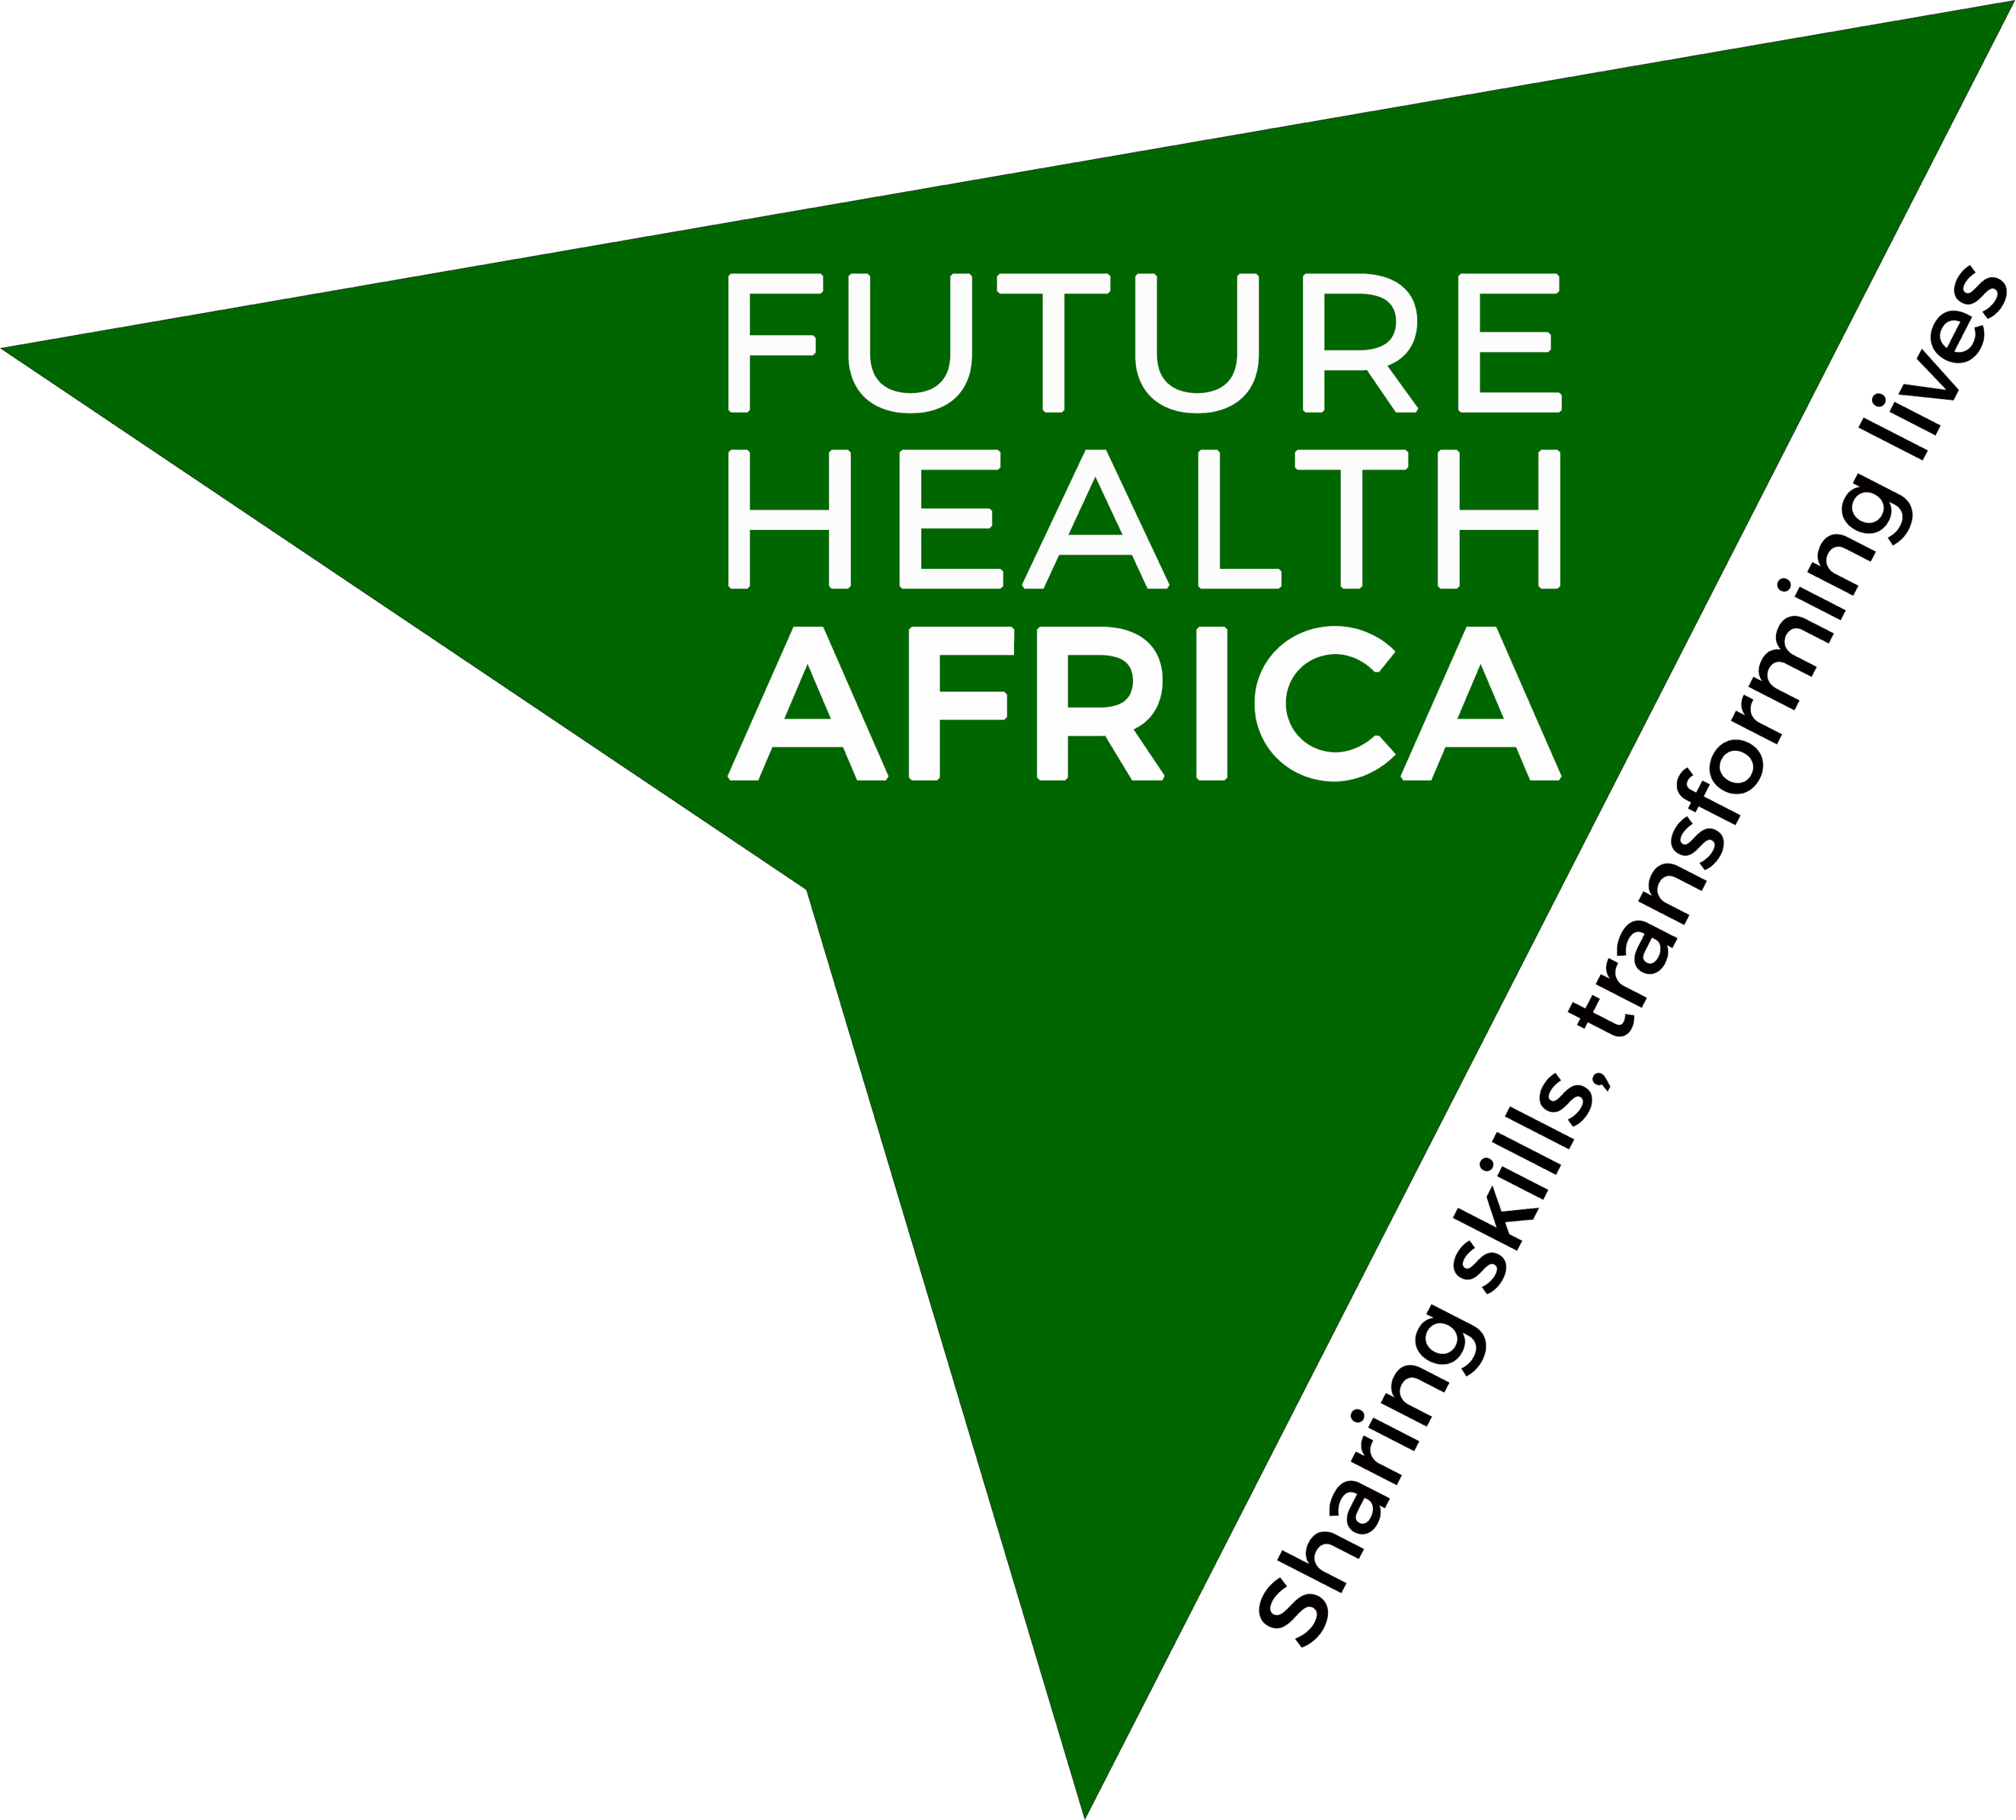 **q4a NEWSLETTER 03 **

**July 2019**



To recap on our various titles/names; our QI/Leadership work started through our Health Partnership work with Laikipia County, funded by the UK Department for International Development (UK Aid). The grants (2012-2107) were managed by THET (the Tropical Health & Education Trust) in the UK, Now we host this work under our UK-based charity called **Future Health Africa.**

Our faculty delivering this work is called q4a (Quality for All) and currently we deliver 1 course – in 2 parts. This is the SPRINGBOARD programme; Foundation & Advanced. See [www.futurehealthafrica.org](http://www.futurehealthafrica.org) for more information.

We are delighted to have celebrated 10 years of working with Laikipia County earlier this year!

**Springboard Courses update**

Our UK Aid grants finished in April 2017, but we were delighted that our contribution was sufficiently valued by the Laikipia County Government that they decided to fund some more SPRINGBOARD courses themselves and these took place in October /November 2018. More QI projects were established including

* improving pain after childbirth
* improving nursing care records
* improving internal referral processes for radiological investigations
* reducing waiting times/improving flow in the OP/Casualty/Emergency Eepartment
* establishing better hospital-wide resuscitation processes

Progress of earlier QI projects established through the SPRINGBOARD programme was reviewed in March 2019 and we were delighted to discover what excellent progress was being made.

**Partnership working**

We were delighted to welcome 3 mentors/QI coaches from **Jacaranda Health** to the Foundation course in Nanyuki. They made a great contribution in mentoring these QI projects and they appreciated the learning they got themselves from the SPRINGBOARD course – a really successful collaboration which we hope will continue as there are very few of us delivering practical training in QI in Kenya.

We continue to work closely with the Laikipia County Government and its new Minister of Health, Dr Joseph Lenai, and hope to run more courses in Nanyuki, Nyahururu and in community settings in 2019-20. We are hopeful that we will be successful in gaining a further DFID grant to support this work.

We are grateful to **Dr Charles Kandie**, who was Head of the Division of Health Standards and Quality at the central Ministry of Health who has been a great supporter of our work – we wish him well in his new role and look forward to meeting with his successor.

We were grateful to him for the invitation to attend the launch of the adoption of the Lancet Global Health Commission High Quality Health Systems report. This was launched by Kenya’s First Lady, Margaret Kenyatta, one of the Commissioners of the report. Kenya is showing great insight in attaching the quality agenda to the roll-out of Universal Health Coverage (UHC).

**An honour**

It was a great privilege for q4a lead Dr Kerri Jones to be invited to be a founder member of the newly formed **Society for Quality in Healthcare for Kenya** (**SQHK).**

Kerri was invited to present a summary of the 3 major

international reports on quality in healthcare published in 2018 to the Society in February 2019.

Dr Lydia Okutoyi, Head of Quality at Kenyatta National Hospital who is establishing this important Society, has become a valued advisor to our work.

**Presentations**

Congratulations to Christine Musee, Senior Nurse at Kenyatta National Hospital and a member of the **q4a** faculty, on having her abstract on the Springboard programme accepted for the forthcoming **ECSACON CONFERENCE** in Kisumu on 7/8th August, 2019. She did an excellent evaluation of the programme and dissemination of her findings is very important to us.

Dr Mary Nduta and Dr Kerri Jones presented the work of Future Health Africa and our QI/Leadership work at an international conference **‘Reciprocal Benefits of Global Health partnerships’** held at Plymouth University, UK in May 2019.

**Faculty updates**

**Joiners**

We are delighted to welcome **Tim Spring**, a dynamic young NHS manager and QI expert, to the faculty. Although he hasn’t yet visited Kenya, he has been helping behind the scenes with developing the **q4a** work and will hopefully join us in Kenya soon.

Lead Faculty currently are

Foundation course: Kate Silvester, Jane Pyle

Advanced course: Penny Humphris, Nick Roberts, Christine Musee

They are supported by Kerri Jones, the q4a lead.

Dr Timothy Panga remains our Kenya lead and Dr Mary Nduta has also started to support the programme in Kenya. We are very grateful to them.

We hope to develop a Training of Trainers programme and increase the Kenyan Faculty over time.

**Spreading the QI message!**

**q4a’s** website presence is now hosted on the **Future Health Africa** website [www.futurehealthafrica.org](http://www.futurehealthafrica.org)

**Future Plans**

We continue to seek funding and apply for grants to support our work.

We are also expanding the teaching material in our Advanced course workbook and drafting a training of trainers outline.

Application results are awaited for a DFID application to test spread of teaching QI/Leadership methodology to community settings in Laikipia and to test spread to another county, Marsabit, where the Governor Mohamed Mohamud Ali has agreed to fund a Springboard Programme. Our plan is to do a really good

Evaluation of the spread and to contribute to developing County Policy for implementation of QI in line with the Kenya Quality Model for Health.

We are also engaging with Plymouth University in SW England and are applying for research grants. We are hoping to build on early talks to collaborate with AMREF International University. This is an important new development for us.

Please let us know if you know pf nay other opportunities to develop our work.

**If anyone would like to share any stories in this newsletter, please contact** [**info@futurehealthafrica.org**](mailto:info@futurehealthafrica.org)